The kingdom of Ghana

NOTES
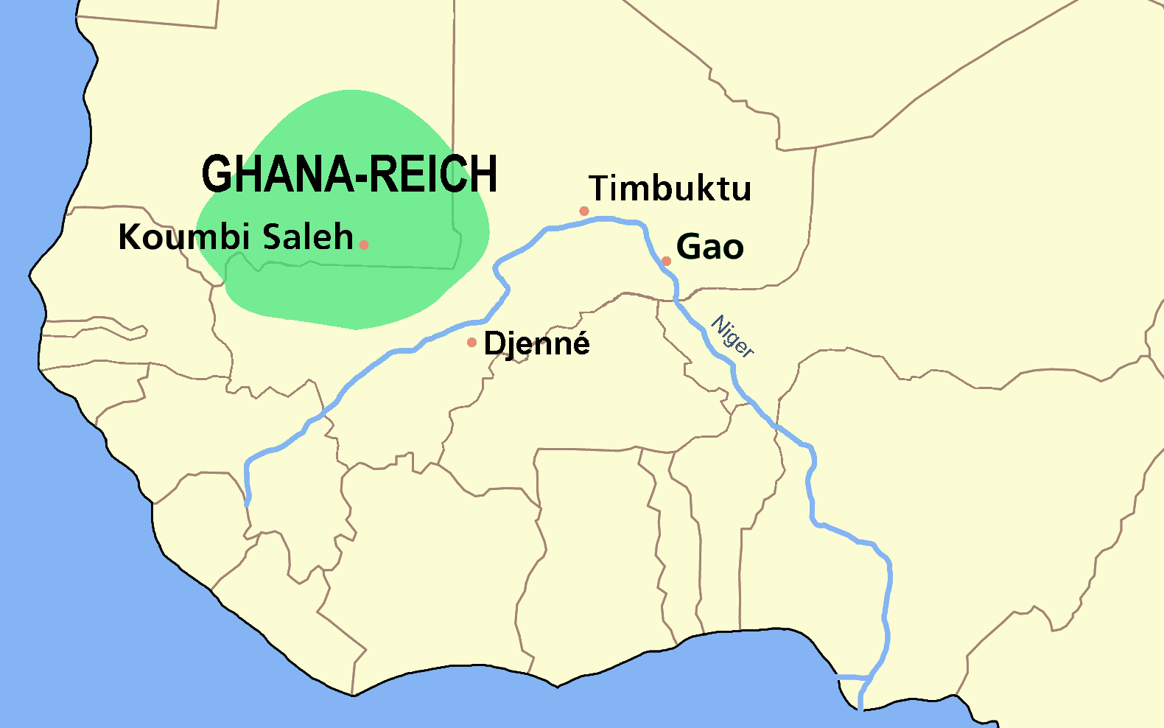
Made iron swords, spears, and lances to subdue neighboring peoples and to gain control over West Africa’s major trade routes

Caravans brought salt south to Ghana and returned north with gold

Power of kings of Ghana rested on their ability to tax all trade passing through the region, especially the gold-salt trade

Rulers and nobles were further enriched by using captives of war as slaves

1076 they were invaded by Muslims from North Africa which weakened the kingdom

Important People of Ghana

Soninke People – Farmers who united together to eventually form the Kingdom of Ghana and later, the Empire of Ghana. They developed iron tools which made farming easier.

Tunka Manin – Ruled the Empire of Ghana around the year 1068. Was named king after the passing of his uncle. Considered to be the last effective King of Ghana before its decline.
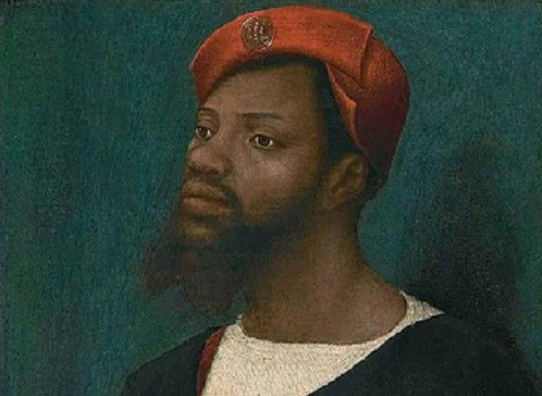

The Kingdom of Mali

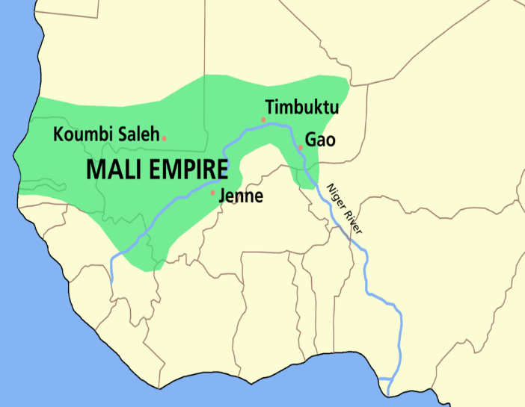
NOTES
Rulers brought both gold and salt mines under their direct control

Rulers converted to Islam, although most people did not; Muslim scholarship flourished

Mansa Musa…
- expanded kingdom greatly
- Made a religious pilgrimage to Mecca
- Brought Muslim scholars and architects back to Mali with him

Timbuktu became an important center of several important universities and attracted student from Europe, Asia, and Africa

Important People of mali
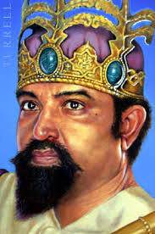
Sundiata Keita – Expanded the kingdom of Mali to include the Kingdom of Ghana and the West African gold fields. He divided up his kingdom into provinces each headed by a general. His name literally means, “Hungering Lion.”

Ibn Battuta - A medieval Berber traveler and scholar who is widely recognized as one of the greatest travelers of all time.
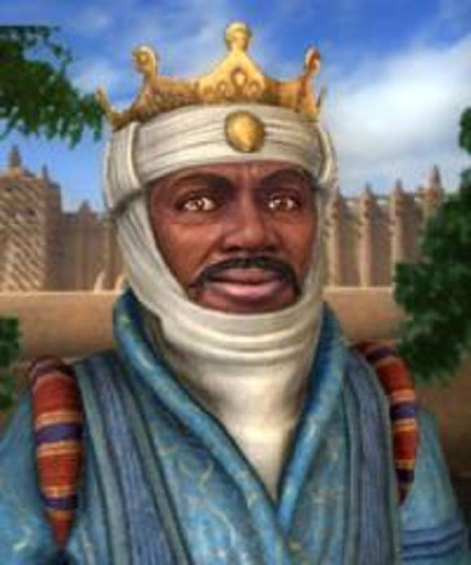

Mansa Musa –. The most famous ruler of Mali and one of the richest people in the history of the world. Brought stability to Mali and under his reign, Mali reached the height of its wealth, power, and fame.
The Kingdom of Songhai

NOTES
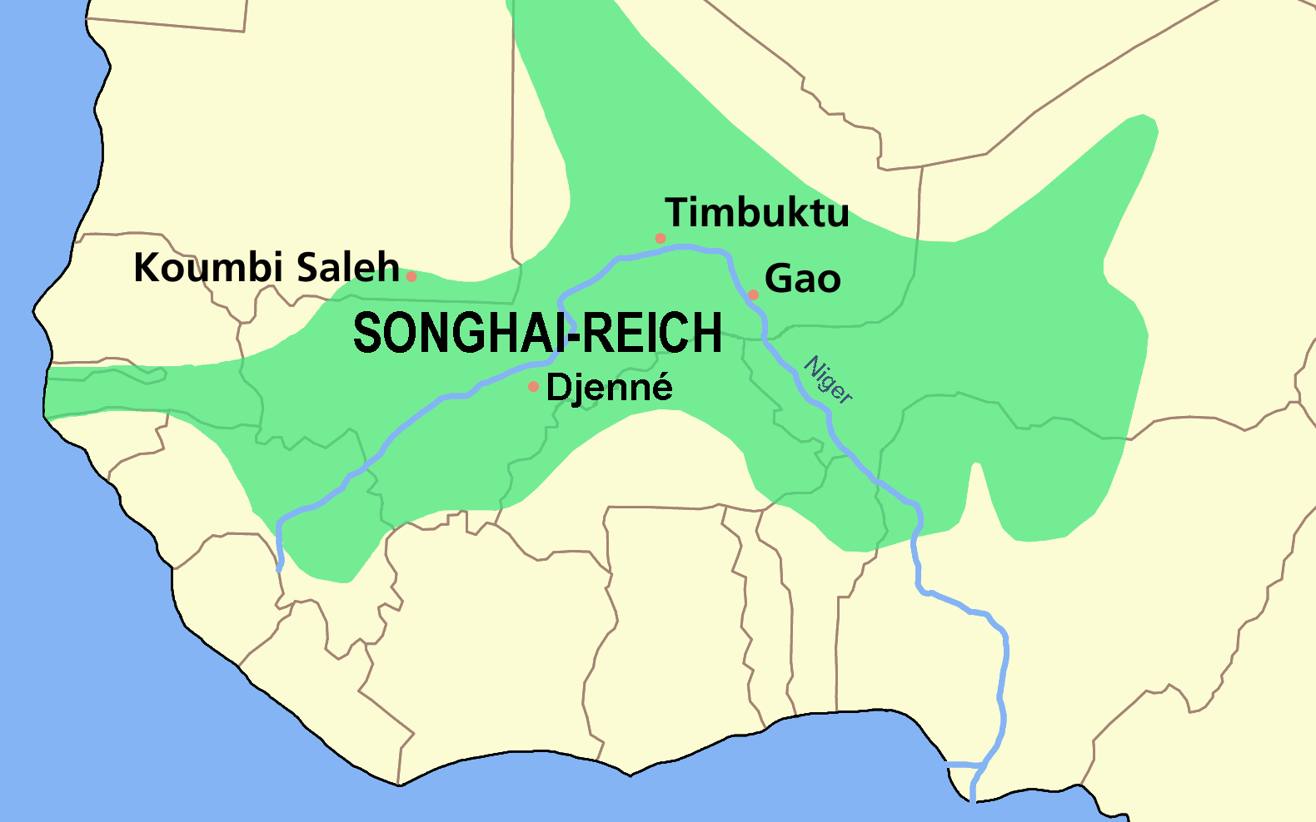
Grew rich from trade across Sahara Desert (salt and gold)

Divided into provinces

Created a navy and soldiers on horseback (cavalry)

Expanded its trading networks as far as Europe and Asia

Continued to flourish as a center of Muslim scholarship and many subjects were Muslim

Morocco conquered Songhai in 1591

Important People of SONghai
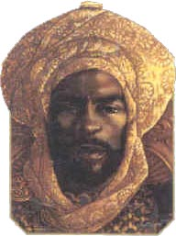
- Sunni Ali – Became the first great leader of the Songhai Empire by conquering land previously occupied by the Empire of Mali, such as Timbuktu and Djenne. He brought stability to the region by uniting everyone in his empire.

- The Berbers - A group of people from North Africa that helped the Songhai Empire grow by their willingness to trade with Songhai. Many Berbers were Muslim as were many of the people of Songhai.

- Askia the Great – Developed a centralized government which included a new system of laws, a larger military, and encouraged scholarship and learning. He brought stability to the Songhai Empire when he succeeded Sunni Ali in 1493.
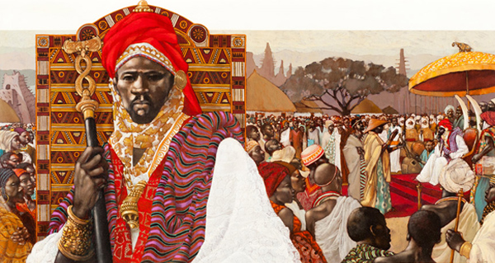

GHANA
MALI
SONGHAI

